Link for SQL : https://www.tutorialspoint.com/sql_certificate/using_single_row_functions.htm
Difference between where and having in SQL.

SET Operator in Oracle.
UNION
UNION ALL
MINUS
INTERSECT

A WHERE clause is used to filter rows BEFORE the GROUPING action (i.e., before the calculation of the aggregate functions).
A HAVING clause filters rows AFTER the GROUPING action (i.e., after the calculation of the aggregate functions).
Find the latest record inserted to DB by using SQL that tables does not have the
Primary key.
/select * from src_emp where rowid in (select min(rowID)from src_emp); where empno =7499);
EMPNO ENAME SAL COMM DEPTNO
----- ---------- ---------- ---------- ----------
7499 SAMPATH 2000 20 4
SQL query find the duplicate records
select * from src_emp where rowid not in ( select min(rowid) from src_emp group by empno);

select FIRST_NAME,count(*) as count from src_employee having count(*) > 1 group by first_name;

SELECT code, user_name, COUNT(user_name) AS NumOccurrences FROM tbl_user GROUP BY code, user_name HAVING ( COUNT(user_name) > 1 )
select * from src_emp where rowid not in (select max(rowid) from src_emp group by ENAME);

How would you go about deleting the duplicate records?
A. You could do it in a number of steps as shown below.
Create a temporary table.
Insert the unique records into the temporary table.
Delete the records from the original table.
Insert the saved single records from the temporary table back to the original table

RANK and DENSE RANK = Are Analytic functions
Let's assume we want to assign a sequential order, or rank, to people within a department based on salary, we might use the RANK function like.
SELECT empno,
deptno,
sal,
RANK() OVER (PARTITION BY deptno ORDER BY sal) "rank"
FROM emp;

EMPNO DEPTNO SAL rank
---------- ---------- ---------- ----------
7934 10 1300 1
7782 10 2450 2
7839 10 5000 3
7369 20 800 1
7876 20 1100 2
7566 20 2975 3
7788 20 3000 4
7902 20 3000 4
7900 30 950 1
7654 30 1250 2
7521 30 1250 2
7844 30 1500 4
7499 30 1600 5
7698 30 2850 6

SQL>
What we see here is where two people have the same salary they are assigned the same rank. When multiple rows share the same rank the next rank in the sequence is not consecutive.

DENSE_RANK
byThe DENSE_RANK function acts like the RANK function except that it assigns consecutive ranks.
SELECT empno,
deptno,
sal,
DENSE_RANK() OVER (PARTITION BY deptno ORDER BY sal) "rank"
FROM emp;

EMPNO DEPTNO SAL rank
---------- ---------- ---------- ----------
7934 10 1300 1
7782 10 2450 2
7839 10 5000 3
7369 20 800 1
7876 20 1100 2
7566 20 2975 3
7788 20 3000 4
7902 20 3000 4
7900 30 950 1
7654 30 1250 2
7521 30 1250 2
7844 30 1500 3
7499 30 1600 4
7698 30 2850 5
SQL LEAD and NVL function

NVL Example
Table Sales_Data
Store_Name | Sales
Store A | 300
Store B | NULL
Store C | 150
The following SQL,
SELECT SUM (NVL(Sales,100)) FROM Sales_Data;
would generate result below:
SUM (NVL(Sales,100))
550
This is because NULL has been replaced by 100 via the NVL function, hence the sum of the 3 rows is 300 + 100 + 150 = 550.
SELECT last_name, hire_date,LEAD(hire_date, 1) OVER (ORDER BY hire_date) AS "NextHired" FROM employees WHERE department_id = 30;

------------------------- --------- ---------
Raphaely 07-DEC-94 18-MAY-95
Khoo 18-MAY-95 24-JUL-97
Tobias 24-JUL-97 24-DEC-97
Baida 24-DEC-97 15-NOV-98
Himuro 15-NOV-98 10-AUG-99
Colmenares 10-AUG-99

Insert multiple rows in SQL Oracle
insert into emp (employeeid,SLARY )

select 86469,82000 from dual union all

select 86447,68500 from dual union all select 86475,83200 from dual;

Insert multiple rows in MYSQL
insert into emp (employeeid,SLARY ) values (86465,65950),
(86485,62100);

Find the second highest salary
SELECT MAX(Salary) FROM Employee
WHERE Salary NOT IN (SELECT MAX(Salary) FROM Employee )

Select * from dba_tables will display all tables in oracle wrt to that server.

Select table_name from user_tables will display all table.

Dba_users table will display user name, status etc for respective DB

Unlock the user using below command
alter user <HR> identified by sampath account unlock;
Note : You should be having the admin privilege to do that .
Find the last update table in Oracle DB .
- Ask your DBA to enable the audit on specific table that will give u when this table is last update . You can query using the select * from user_tab_modifications. Sample screen print below.
- If you enable audit taril on all table the performance will reduce so majority of the project does not do in real time.
Initiate the audit is (audit insert,update,delete on tgt_sreenu.tgt_region;)

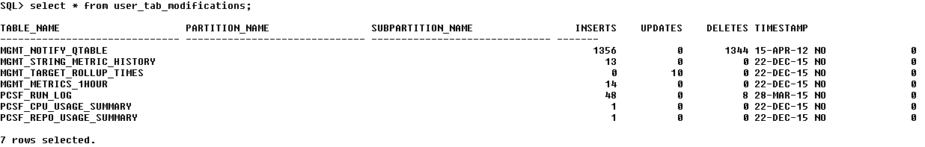

Column under user_tab_modifications table is
Name Null? Type
----------------------------------------- -------- ----------------------------
TABLE_NAME VARCHAR2(30)
PARTITION_NAME VARCHAR2(30)
SUBPARTITION_NAME VARCHAR2(30)
INSERTS NUMBER
UPDATES NUMBER
DELETES NUMBER
TIMESTAMP DATE
TRUNCATED VARCHAR2(3)
DROP_SEGMENTS NUMBER

View the number of users in Data base , use the below query
Select * from all_users
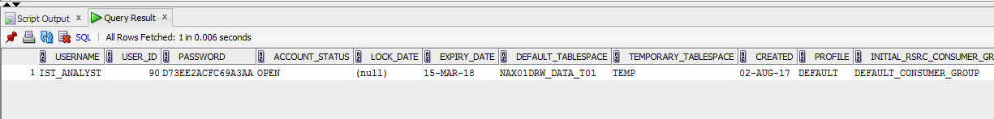

Create table structure along with data
====================================
CREATE TABLE new_table AS SELECT * FROM old_table

Create the table with only structure
=======================================
CREATE TABLE new_table AS SELECT * FROM old_table where 1=2 to copy only table structure

Create a Index on Table
========================
Create index PRODUCT_ID1 on BACKUP_SRC_DLY_TRANSACTION1(PRODUCT_ID);

Create Unique Index on Table
==============================
CREA
TE UNIQUE INDEX dept_unique_index ON dept(dname)

Find index Created table
SELECT index_name FROM user_indexes ;

SUBSTRING in SQL
======================
The SQL Substring feature is a function that enables parts of strings to be accessed.
For example, the function SUBSTRING('212-555-1234', 9 , 4) returns: '1234'
It returns 4 characters starting in position 9.

Find max slary wrt with using the max range in select statement.
===============================================
select EMPLOYEEID,SLARY from emp1 where slary in (select max(slary) from emp1 group by EMPLOYEEID);

What is a Stored Procedure
============================
A stored procedure or in simple a proc is a named PL/SQL block which performs one or more specific task. This is similar to a procedure in other programming languages.
A procedure has a header and a body. The header consists of the name of the procedure and the parameters or variables passed to the procedure. The body consists or declaration section, execution section and exception section similar to a general PL/SQL Block.
A procedure is similar to an anonymous PL/SQL Block but it is named for repeated usage.
We can pass parameters to procedures in three ways.
1) IN-parameters
2) OUT-parameters
3) IN OUT-parameters
A procedure may or may not return any value.

About Cusrsor
===============
What are Cursors?
A cursor is a temporary work area created in the system memory when a SQL statement is executed. A cursor contains information on a select statement and the rows of data accessed by it.

This temporary work area is used to store the data retrieved from the database, and manipulate this data. A cursor can hold more than one row, but can process only one row at a time. The set of rows the cursor holds is called the active set.

There are two types of cursors in PL/SQL:

Implicit cursors
These are created by default when DML statements like, INSERT, UPDATE, and DELETE statements are executed. They are also created when a SELECT statement that returns just one row is executed.
Explicit cursors
They must be created when you are executing a SELECT statement that returns more than one row. Even though the cursor stores multiple records, only one record can be processed at a time, which is called as current row. When you fetch a row the current row position moves to next row.
Both implicit and explicit cursors have the same functionality, but they differ in the way they are accessed.

Implicit Cursors: Application
When you execute DML statements like DELETE, INSERT, UPDATE and SELECT statements, implicit statements are created to process these statements.
Oracle provides few attributes called as implicit cursor attributes to check the status of DML operations. The cursor attributes available are %FOUND, %NOTFOUND, %ROWCOUNT, and %ISOPEN.
For example, When you execute INSERT, UPDATE, or DELETE statements the cursor attributes tell us whether any rows are affected and how many have been affected.
When a SELECT... INTO statement is executed in a PL/SQL Block, implicit cursor attributes can be used to find out whether any row has been returned by the SELECT statement. PL/SQL returns an error when no data is selected.
The status of the cursor for each of these attributes are defined in the below table.
Attributes | Return Value | Example
%FOUND | The return value is TRUE, if the DML statements like INSERT, DELETE and UPDATE affect at least one row and if SELECT ….INTO statement return at least one row. | SQL%FOUND
%FOUND | The return value is FALSE, if DML statements like INSERT, DELETE and UPDATE do not affect row and if SELECT….INTO statement do not return a row. | SQL%FOUND
%NOTFOUND | The return value is FALSE, if DML statements like INSERT, DELETE and UPDATE at least one row and if SELECT ….INTO statement return at least one row. | SQL%NOTFOUND
%NOTFOUND | The return value is TRUE, if a DML statement like INSERT, DELETE and UPDATE do not affect even one row and if SELECT ….INTO statement does not return a row. | SQL%NOTFOUND
%ROWCOUNT | Return the number of rows affected by the DML operations INSERT, DELETE, UPDATE, SELECT | SQL%ROWCOUNT

For Example: Consider the PL/SQL Block that uses implicit cursor attributes as shown below:
DECLARE var_rows number(5);
BEGIN
UPDATE employee
SET salary = salary + 1000;
IF SQL%NOTFOUND THEN
dbms_output.put_line('None of the salaries where updated');
ELSIF SQL%FOUND THEN
var_rows := SQL%ROWCOUNT;
dbms_output.put_line('Salaries for ' || var_rows || 'employees are updated');
END IF;
END;
In the above PL/SQL Block, the salaries of all the employees in the ‘employee’ table are updated. If none of the employee’s salary are updated we get a message 'None of the salaries where updated'. Else we get a message like for example, 'Salaries for 1000 employees are updated' if there are 1000 rows in ‘employee’ table.
What is a Trigger?
A trigger is a pl/sql block structure which is fired when a DML statements like Insert, Delete, Update is executed on a database table. A trigger is triggered automatically when an associated DML statement is executed.
Syntax of Triggers

Syntax for Creating a Trigger
CREATE [OR REPLACE ] TRIGGER trigger_name
{BEFORE | AFTER | INSTEAD OF }
{INSERT [OR] | UPDATE [OR] | DELETE}
[OF col_name]
ON table_name
[REFERENCING OLD AS o NEW AS n]
[FOR EACH ROW]
WHEN (condition)
BEGIN
--- sql statements
END;

Second higest salary from table
select max(slary) from emp where slary < (select max(slary) from emp);
SELECT * FROM (SELECT [Salary],(DENSE_RANK() OVER
(ORDER BY [Salary] DESC)) AS rnk FROM [Table1] GROUP BY [Num]
) AS A.ktt853
WHERE A.rnk = 2

Find second min salary from table
select min(slary) from emp where slary > (select min(slary) from emp);

Query Tuning

Index is created for any column

Index has Unique , Clustred and Non cluster

Basic Difference
Function must return a value but in Stored Procedure it is optional( Procedure can return zero or n values).
Functions can have only input parameters for it whereas Procedures can have input/output parameters .
Function takes one input parameter it is mandatory but Stored Procedure may take o to n input parameters..
Functions can be called from Procedure whereas Procedures cannot be called from Function.
Advance Difference
Procedure allows SELECT as well as DML(INSERT/UPDATE/DELETE) statement in it whereas Function allows only SELECT statement in it.
Procedures can not be utilized in a SELECT statement whereas Function can be embedded in a SELECT statement.
Stored Procedures cannot be used in the SQL statements anywhere in the WHERE/HAVING/SELECT section whereas Function can be.
Functions that return tables can be treated as another rowset. This can be used in JOINs with other tables.
Inline Function can be though of as views that take parameters and can be used in JOINs and other Rowset operations.
Exception can be handled by try-catch block in a Procedure whereas try-catch block cannot be used in a Function.
We can go for Transaction Management in Procedure whereas we can't go in Function.

SELF join example

Run the dependency work flow .
Event wait or work lets

Find nth Higest Salary
select * from (select slary ,dense_rank() over(order by slary desc) hg from emp order by slary desc)
where hg <=3;
Group by
1. Reduces the no. of records
2. In select we need to use only columns which are used in group by. but we can use aggregate functions.
3. In filter condition we need to use having clause instead of where clause.

Explain Plan Details

Synatx,
Explain plan for <SQL QUERY>
Explain plan for select * from src_emp

Select plan_table_output from table (dbms_xplan.display(‘plan_table’,null,’basic’));
plan table name (default 'PLAN_TABLE')
statement_id (default null means the last statement inserted into the plan table)
format, controls the amount of information displayed (default is 'TYPICAL')

select plan_table_output from table(dbms_xplan.display_cursor(null,null, ’basic’));

select plan_table_output from table (dbms.xplan.display(‘plan_table’, null, ’basic’));
select plan_table_output from table dbms_xplan.display_cursor(NULL,NULL,'typical'));

Partition By
1.No. of records will not be reduced. Instead of that it will add one extra column.
2. In select we can use N no. of columns. No restrictions.
3.We can use where clause in filter condition apart from partition column.
Control statements are SQL statements that allow SQL to be used in a manner similar to writing a program in a structured programming language. SQL control statements provide the capability to control the logic flow, declare and set variables, and handle warnings and exceptions. Some SQL control statements include other nested SQL statements.
SQL-control-statement:

|--+-assignment-statemen
+-CALL-statement
+-CASE-statement
+-compound-statement
+-FOR-statement-------------+
+-GET DIAGNOSTICS-statement-+
+-GOTO-statement------------+
+-IF-statement--------------+
+-ITERATE-statement---------+
+-LEAVE-statement-----------+
+-LOOP-statement------------+
+-REPEAT-statement----------+
+-RESIGNAL-statement--------+
+-RETURN-statement----------+
+-SIGNAL-statement----------+
'-WHILE-statement-----------'
Control statements are supported in SQL procedures, SQL functions, and SQL triggers.
Index of Insert Statement.
The number of indexes on a table is the most dominant factor for insert performance. The more indexes a table has, the slower the execution becomes. The insert statement is the only operation that cannot directly benefit from indexing because it has no where clause.
Adding a new row to a table involves several steps. First, the database must find a place to store the row. For a regular heap table—which has no particular row order—the database can take any table block that has enough free space. This is a very simple and quick process, mostly executed in main memory. All the database has to do afterwards is to add the new entry to the respective data block.
If there are indexes on the table, the database must make sure the new entry is also found via these indexes. For this reason it has to add the new entry to each and every index on that table. The number of indexes is therefore a multiplier for the cost of an insert statement.Moreover, adding an entry to an index is much more expensive than inserting one into a heap structure because the database has to keep the index order and tree balance. That means the new entry cannot be written to any block—it belongs to a specific leaf node. Although the database uses the index tree itself to find the correct leaf node, it still has to read a few index blocks for the tree traversal.
Once the correct leaf node has been identified, the database confirms that there is enough free space left in this node. If not, the database splits the leaf node and distributes the entries between the old and a new node. This process also affects the reference in the corresponding branch node as that must be duplicated as well. Needless to say, the branch node can run out of space as well so it might have to be split too. In the worst case, the database has to split all nodes up to the root node. This is the only case in which the tree gains an additional layer and grows in depth.
The index maintenance is, after all, the most expensive part of the insert operation. That is also visible in Figure 8.1: the execution time is hardly visible if the table does not have any indexes. Nevertheless, adding a single index is enough to increase the execute time by a factor of a hundred. Each additional index slows the execution down further.

Considering insert statements only, it would be best to avoid indexes entirely—this yields by far the best insert performance. However tables without indexes are rather unrealistic in real world applications. You usually want to retrieve the stored data again so that you need indexes to improve query speed. Even write-only log tables often have a primary key and a respective index.
Nevertheless, the performance without indexes is so good that it can make sense to temporarily drop all indexes while loading large amounts of data—provided the indexes are not needed by any other SQL statements in the meantime. This can unleash a dramatic speed-up which is visible in the chart and is, in fact, a common practice in data warehouses.
Indexes primary use is to find records faster. This comes at a cost because the index must be modified whenever an insert or update occurs. This cost can be reduced by putting all of the indexes on a separate file group located on different physical spindles (drives) than the tables (I will show you how to do this in a later post).
I have recommend adding the recommended indexes until your ISV SQL Server database is within 5 percent of the maximum performance that Database Engine Tuning Advisor identifies. Getting the last 5 percent often means adding so many indexes that index maintenance consumes so many resources that you lose performance.
Group by function and having caluse
Let's start with the GROUP BY clause. You can use this to group values from a column, and, if you wish, perform calculations on that column. Let's look at a simple example:
mysql> SELECT poet,SUM(copies_in_stock) FROM writer GROUP BY poet;
| poet | SUM(copies_in_stock) |
| Douglas Livingstone | 23 |
| Mongane Wally Serote | 13 |
Here, there are many records containing the same poet data (which is the reason why it is not normalized). The GROUP BY function puts all of them together, allowing you to perform a calculation, such as the SUM() used to find the total number of copies_in_stock. Here is another example:
mysql> SELECT poet,copies_in_stock FROM writer GROUP BY poet;
| poet | copies_in_stock |
| Douglas Livingstone | 21 |
| Mongane Wally Serote | 3 |

Just what are the values in the copies_in_stock column referring to? What do they mean? Perhaps looking at the full list of records may shed some light.
mysql> SELECT * FROM writer;
| poet | anthology | copies_in_stock |
| Mongane Wally Serote | Tstetlo | 3 |
| Mongane Wally Serote | No Baby Must Weep | 8 |
| Mongane Wally Serote | A Tough Tale | 2 |
| Douglas Livingstone | The Skull in the Mud | 21 |
| Douglas Livingstone | A Littoral Zone | 2 |
The results are being grouped by the field poet, but there is no sensible way to return a value from the copies_in_stock field. Performing a mathematical function, such as SUM() or AVG() would make sense, but what exactly is this query asking of the database? I don't know, and neither does MySQL, so it simply returns the first result it finds (other DBMS' may return different results). The result returned means nothing, and may not be consistent, as it depends upon the order the DBMS happens to have placed and found the record, so there is no point in running a query like this.
Here is another example, showing a number of common functions:
mysql> SELECT poet,
MAX(copies_in_stock) max,
MIN(copies_in_stock) min,
AVG(copies_in_stock) avg,
SUM(copies_in_stock) sum
FROM writer GROUP BY poet;
| poet | max | min | avg | sum |
| Douglas Livingstone | 21 | 2 | 11.5000 | 23 |
| Mongane Wally Serote | 8 | 2 | 4.3333 | 13 |
The column titles have been given aliases to make the output more readable (note that aliases more often have the keyword AS in front of them, so this identical query may be more familiar to some):
mysql> SELECT poet,
MAX(copies_in_stock) AS max,
MIN(copies_in_stock) AS min,
AVG(copies_in_stock) AS avg,
SUM(copies_in_stock) AS sum
FROM writer GROUP BY poet;
| poet | max | min | avg | sum |
| Douglas Livingstone | 21 | 2 | 11.5000 | 23 |
| Mongane Wally Serote | 8 | 2 | 4.3333 | 13 |

The HAVING clause
Beginners are commonly confused about the difference between the WHERE and HAVING clauses. They are both conditions, and look similar after all. To start with, let's have a look at these four queries:
mysql> SELECT poet,
MAX(copies_in_stock) AS max,
MIN(copies_in_stock) AS min,
AVG(copies_in_stock) AS avg,
SUM(copies_in_stock) AS sum
FROM writer WHERE copies_in_stock > 5 GROUP BY poet;
| poet | max | min | avg | sum |
| Douglas Livingstone | 21 | 21 | 21.0000 | 21 |
| Mongane Wally Serote | 8 | 8 | 8.0000 | 8 |
mysql> SELECT poet,
MAX(copies_in_stock) AS max,
MIN(copies_in_stock) AS min,
AVG(copies_in_stock) AS avg,
SUM(copies_in_stock) AS sum
FROM writer GROUP BY poet HAVING copies_in_stock > 5;
ERROR 1054 (42S22): Unknown column 'copies_in_stock' in 'having clause'
The first query only returns results where there are more than five copies in stock. Since each poet only has one title that abides by this condition, the DBMS applies the mathematical calculations to just that one record. Consequently, the results of the MAX(), MIN(), AVG() and SUM() calculations are all the same. The second query attempts to do the same, but using a HAVING clause instead of a WHERE clause. It fails, because MySQL expects a column mentioned in a HAVING clause to be present in the list of columns (see below for a discussion on changes in this behavior with MySQL 5.0.2). This could include a function, so the following query works:
mysql> SELECT poet,
MAX(copies_in_stock) AS max,
MIN(copies_in_stock) AS min,
AVG(copies_in_stock) AS avg,
SUM(copies_in_stock) AS sum
FROM writer GROUP BY poet HAVING max > 5;
| poet | max | min | avg | sum |
| Douglas Livingstone | 21 | 2 | 11.5000 | 23 |
| Mongane Wally Serote | 8 | 2 | 4.3333 | 13 |

Note that the results in this case are identical, but this would not necessarily always be the case. Let us add another record to illustrate, and then run the same two queries again:
mysql> INSERT INTO writer VALUES('Douglas Livingstone',
'Giovanni Jacopo Meditates on the High-IQ Haiku',9);

mysql> SELECT poet,
MAX(copies_in_stock) AS max,
MIN(copies_in_stock) AS min,
AVG(copies_in_stock) AS avg,
SUM(copies_in_stock) AS sum
FROM writer GROUP BY poet HAVING max > 5;

| poet | max | min | avg | sum |
| Douglas Livingstone | 21 | 2 | 10.6667 | 32 |
| Mongane Wally Serote | 8 | 2 | 4.3333 | 13 |
2 rows in set (0.00 sec)

mysql> SELECT poet,
MAX(copies_in_stock) AS max,
MIN(copies_in_stock) AS min,
AVG(copies_in_stock) AS avg,
SUM(copies_in_stock) AS sum
FROM writer WHERE copies_in_stock > 5 GROUP BY poet;
| poet | max | min | avg | sum |

| Douglas Livingstone | 21 | 9 | 15.0000 | 30 |
| Mongane Wally Serote | 8 | 8 | 8.0000 | 8 |

If you are unclear about why this is the case, take some time to reflect on the differences. The first query (with the condition in the HAVING clause) applies the condition after all records have been returned. Since both of the records have a max greater than 5, there is effectively no limiting of the results. The results are the same as they would be without any conditions, as below:
mysql> SELECT poet,
MAX(copies_in_stock) AS max,
MIN(copies_in_stock) AS min,
AVG(copies_in_stock) AS avg,
SUM(copies_in_stock) AS sum
FROM writer GROUP BY poet;
| poet | max | min | avg | sum |
| Douglas Livingstone | 21 | 2 | 10.6667 | 32 |
| Mongane Wally Serote | 8 | 2 | 4.3333 | 13 |

The second query, with the condition in the WHERE clause, applies the condition before starting to calculate the results of the functions. Therefore, for Douglas Livingstone, only two results match the condition, and the functions then go to work on this limited set of results. Have a look at the following results, which illustrate how the WHERE clause determines the output.
mysql> SELECT * FROM writer WHERE copies_in_stock > 5;
| poet | anthology | copies_in_stock |
| Mongane Wally Serote | No Baby Must Weep | 8 |
| Douglas Livingstone | The Skull in the Mud | 21 |
| Douglas Livingstone | Giovanni Jacopo Meditates on the High-IQ | 9 |
The AVG(), for example, of the two Douglas Livingstone results is 15, and the MIN() is 9, matching with the results in the earlier query.
Here are two more examples, showing the difference between HAVING and WHERE:
mysql> SELECT poet,
MAX(copies_in_stock) AS max,
MIN(copies_in_stock) AS min,
AVG(copies_in_stock) AS avg,
SUM(copies_in_stock) AS sum
FROM writer GROUP BY poet HAVING poet > 'E';
| poet | max | min | avg | sum |
| Mongane Wally Serote | 8 | 2 | 4.3333 | 13 |
1 row in set (0.00 sec)

mysql> SELECT poet,
MAX(copies_in_stock) AS max,
MIN(copies_in_stock) AS min,
AVG(copies_in_stock) AS avg,
SUM(copies_in_stock) AS sum
FROM writer WHERE poet > 'E' GROUP BY poet;
| poet | max | min | avg | sum |
| Mongane Wally Serote | 8 | 2 | 4.3333 | 13 |
Note that they both return the same results. The poet column appears in the list of columns, so poets with a name starting after 'E' are returned. In this case, it makes no difference to the results which way you apply the condition - the same records are always excluded. However, the positioning of the condition does make a difference to the optimization. Since the WHERE clause is carried out first, while the HAVING clause is carried out last, after all optimizations, it usually makes more sense to place a condition in the WHERE clause, and save the HAVING clause for conditions that are applied to fields,

Changes to the HAVING clause in MYSQL 5.0.2
Older versions of MySQL allowed the HAVING clause to refer to any field listed after the SELECT statement. The SQL standard requires the HAVING clause to also accept fields mentioned in the GROUP BY column, even if they are not mentioned in the SELECT expression. For example, the following query works in MYSQL 5.0.2 and beyond, but not in earlier versions:
mysql> SELECT SUM(copies_in_stock) sum GROUP BY poet HAVING poet > 'E';
Difference between co related subquery and subquery
subquery: ( subquery executes only once and gives the output to outer query then outer query executes)
select * from emp where deptno in ( select deptno from dept);
co-related query : ( co-related subquery executes for each row returned by main query )
select a.* from emp e
where deptno = ( select deptno from emp a
where a.empno = e.empno);

Oracle Subquery/Correlated Query Examples
A subquery is a SELECT statement which is used in another SELECT statement. Subqueries are very useful when you need to select rows from a table with a condition that depends on the data of the table itself. You can use the subquery in the SQL clauses including WHERE clause, HAVING clause, FROM clause etc.
The subquery can also be referred as nested SELECT, sub SELECT or inner SELECT. In general, the subquery executes first and its output is used in the main query or outer query.
Types of Sub queries:
There are two types of subqueries in oracle:
- Single Row Subqueries: The subquery returns only one row. Use single row comparison operators like =, > etc while doing comparisions.
- Multiple Row Subqueries: The subquery returns more than one row. Use multiple row comparison operators like IN, ANY, ALL in the comparisons.

Single Row Subquery Examples
1. Write a query to find the salary of employees whose salary is greater than the salary of employee whose id is 100?
SELECT EMPLOYEE_ID,
SALARY
FROM EMPLOYEES
WHERE SALARY >
(
SELECT SALARY
FROM EMPLOYEES
WHERE EMPLOYEED_ID = 100
)
2. Write a query to find the employees who all are earning the highest salary?
SELECT EMPLOYEE_ID,
SALARY
FROM EMPLOYEES
WHERE SALARY =
(
SELECT MAX(SALARY)
FROM EMPLOYEES
)
3. Write a query to find the departments in which the least salary is greater than the highest salary in the department of id 200?
SELECT DEPARTMENT_ID,
MIN(SALARY)
FROM EMPLOYEES
GROUP BY DEPARTMENT_ID
HAVING MIN(SALARY) >
(
SELECT MAX(SALARY)
FROM EMPLOYEES
WHERE DEPARTMENT_ID = 200
)

Multiple Row Subquery Examples
1. Write a query to find the employees whose salary is equal to the salary of at least one employee in department of id 300?
SELECT EMPLOYEE_ID,
SALARY
FROM EMPLOYEES
WHERE SALARY IN
(
SELECT SALARY
FROM EMPLOYEES
WHERE DEPARTMENT_ID = 300
)
2. Write a query to find the employees whose salary is greater than at least on employee in department of id 500?
SELECT EMPLOYEE_ID,
SALARY
FROM EMPLOYEES
WHERE SALARY > ANY
(
SELECT SALARY
FROM EMPLOYEES
WHERE DEPARTMENT_ID = 500
)
3. Write a query to find the employees whose salary is less than the salary of all employees in department of id 100?
SELECT EMPLOYEE_ID,
SALARY
FROM EMPLOYEES
WHERE SALARY < ALL
(
SELECT SALARY
FROM EMPLOYEES
WHERE DEPARTMENT_ID = 100
)
4. Write a query to find the employees whose manager and department should match with the employee of id 20 or 30?
SELECT EMPLOYEE_ID,
MANAGER_ID,
DEPARTMENT_ID
FROM EMPLOYEES
WHERE (MANAGER_ID,DEPARTMENT_ID) IN
(
SELECT MANAGER_ID,
DEPARTMENT_ID
FROM EMPLOYEES
WHERE EMPLOYEE_ID IN (20,30)
)
5. Write a query to get the department name of an employee?
SELECT EMPLOYEE_ID,
DEPARTMENT_ID,
(SELECT DEPARTMENT_NAME
FROM DEPARTMENTS D
WHERE D.DEPARTMENT_ID = E.DEPARTMENT_ID
)
FROM EMPLOYEES E

Correlated SubQueries Examples
Correlated sub query is used for row by row processing. The sub query is executed for each row of the main query.
1. Write a query to find the highest earning employee in each department?
SELECT DEPARTMENT_ID,
EMPLOYEE_ID,
SALARY
FROM EMPLOYEES E_0
WHERE 1 =
(
SELECT COUNT(DISTINCT SALARY)
FROM EMPLOYEES E_I
WHERE E_O.DEPARTMENT_ID = E_I.DEPARTMENT_ID
AND E_O.SALARY <= E_I.SALARY
)
2. Write a query to list the department names which have at lease one employee?
SELECT DEPARTMENT_ID,
DEPARTMENT_NAME
FROM DEPARTMENTS D
WHERE EXISTS
(
SELECT 1
FROM EMPLOYEES E
WHERE E.DEPARTMENT_ID = D.DEPARTMENT_ID)
3. Write a query to find the departments which do not have employees at all?
SELECT DEPARTMENT_ID,
DEPARTMENT_NAME
FROM DEPARTMENTS D
WHERE NOT EXISTS
(
SELECT 1
FROM EMPLOYEES E
WHERE E.DEPARTMENT_ID = D.DEPARTMENT_ID)

SQL Query Tuning.

- First see Index is created on the table and join operation is done using the index column.
- Try to use the where clause before the join so that we can minimize the data before going to join.
- Then use the explain plan logic to see how the oracle server is getting the data and time consuming for each sql clause.
Basis on this result where u find oracle server is using more time try to avoid that clause and use other sql class to achieve the result.

Difference Between ROWID AND ROWNUM

Difference between ROWID and ROWNUM.
Row id | RowNum
1.Physical address of the rows.  2.Rowid is permanent  3.Rowid is 16-bit hexadecimal  4.Rowid gives address of rows or records  5. Rowid is automatically generated unique id of a row and it is generated at the time of insertion of row.  6. ROWID is the fastest means of accessing data.  7. They are unique identifiers for the any row in a table. | 1. Rownum is the sequential number, allocated to each returned row during query execution.  2. Rownum is temporary.  3.Rownum is numeric  4.Rownum gives count of records  5. Rownum is an dynamic value automatically  retrieved along with select statement output.  6. It represents the sequential order in which Oracle has retrieved the row.

select plan for
www.informaticacommunityform.com

Case and Switch Statement in Oracle .
CASE expression
WHEN data1 THEN output1
WHEN data2 THEN output1
.
.
.
WHEN dataN THEN outputN
ELSE defaultStatement
Not only the can we have expression in SWITCH CASE but alsoa series of boolean expression. See the sample below
CASE
WHENboolExpression1 THEN output1
WHENboolExpression2 THEN output1
.
.
.
WHENboolExpressionN THEN outputN

ELSE defaultStatement
If you see at the working of Switch case, you can always aska question why to use SWITCH CASE when we already have IF-ELSE statement.
The idea behind this is that it make the code look cleaner and easy to maintain. Apart from this it can d certain things which is either not possible with
IF- ELSE or not very straight forward to achieve using IF-ELSE.
A simple case where Switch Case can used very elegantly is
SELECT
FirstName,
LastName,
BirthDate,
CASE Gender
WHEN'M' THEN 'Male'
WHEN'F' THEN 'Female'
END
FROM Employees
In this example if our employee table Gender column is of length 1, we case easily get the readable format for gender using Swtich Case
instead of doing this same in Code.
Other important place where we can use SWITCH CASE is to provide custom sorting in the SQL.
select distinct cust_blng_hier_id ,CASE cntry_cd when 'US' then 'America'
when 'GB' then 'Great Bretin'
else 'MOW'end country from hier_pnt_tb

This can be done very easily by using Switch Case.

CREATE PROCEDURE GetCustomers ( @ColToSort varchar(150) ) AS
SELECT Customers.CustomerID, Customers.CompanyName, Customers.ContactName,
Customers.ContactTitle
FROM Customers
ORDER BY
CASE WHEN @ColToSort='CompanyName' THEN CompanyName
WHEN @ColToSort='ContactTitle' THENContactTitle
ElSE CustomerID
END

Case Statement example.

case statement
select STATE_CD case when state_Cd ='KA' then sum(population)
when state_Cd='MH' then sum(population)
when state_cd ='AP' then sum(population)
end "SUM_POPULATION" from st_dt group by STATE_CD;

CASE is used to provide if-then-else type of logic to SQL. There are two formats: The first is a Simple CASE expression, where we compare an expression to static values. The second is a Searched CASE expression, where we compare an expression to one or more logical conditions.

Simple CASE Expression
The syntax for a simple CASE expression is:
SELECT CASE ("column_name")
WHEN "value1" THEN "result1"
WHEN "value2" THEN "result2"
...
[ELSE "resultN"]
END
FROM "table_name";
The ELSE clause is optional.
For example, assume we have the following Store_Information table,
Table Store_Information
Store_Name | Sales | Txn_Date
Los Angeles | 1500 | Jan-05-1999
San Diego | 250 | Jan-07-1999
San Francisco | 300 | Jan-08-1999
Boston | 700 | Jan-08-1999
if we want to multiply the sales amount from 'Los Angeles' by 2 and the sales amount from 'San Diego' by 1.5, while keeping the sales amount for other stores the same, we would use the following SQL statement using CASE:
SELECT Store_Name, CASE Store_Name
WHEN 'Los Angeles' THEN Sales * 2
WHEN 'San Diego' THEN Sales * 1.5
ELSE Sales
END
"New Sales",
Txn_Date
FROM Store_Information;
"New Sales" is the name given to the column with the CASE statement. This is an example of a simple CASE expression, because the conditions listed, 'Los Angeles' and 'San Diego', are static values.
Result:
Store_Name | New Sales | Txn_Date
Los Angeles | 3000 | Jan-05-1999
San Diego | 375 | Jan-07-1999
San Francisco | 300 | Jan-08-1999
Boston | 700 | Jan-08-1999

Searched CASE Expression
The syntax for a searched CASE expression is:
SELECT CASE
WHEN "condition1" THEN "result1"
WHEN "condition2" THEN "result2"
...
[ELSE "resultN"]
END
FROM "table_name";
The ELSE clause is optional. "Condition" can consist of one or more logical statements.
If we want to define the status of a store's sale based on the following rules:
• If Sales >= 1,000, it's a "Good Day"
• If Sales >= 500 and < 1,000, it's an "OK Day"
• If Sales < 500, it's a "Bad Day"
We can use the following searched CASE expression:
SELECT Store_Name, Txn_Date, CASE
WHEN Sales >= 1000 THEN 'Good Day'
WHEN Sales >= 500 THEN 'OK Day'
ELSE 'Bad Day'
END
"Sales Status"
FROM Store_Information;
Result:
Store_Name | Txn_Date | Sales Status
Los Angeles | Jan-05-1999 | Good Day
San Diego | Jan-07-1999 | Bad Day
San Francisco | Jan-08-1999 | Bad Day
Boston | Jan-08-1999 | OK Day

Create table from different schema for example , Create table from SRC_SREENU in TGT_SREENU user .

We need to give the grant permission to SRC_SREENU using the following command .
Grant all on <table name> to src_sreenu.

create table <table_name> as select * from src_sreenu.<source_tablename>;

Once the user is created in DB like src_sampath .You need to provide grant privileges to user .
Example:
1)create user src_sampath identified by src_sampath
2)grant create session to src_sampath;

Show user will display the current user logged in to DB .
Grant Specific access to user
Grant create

When there is an online transaction is going on with DB like delete , If mapping is trying to run and update or insert will get the error message like ORA-00054, from what appears to be a locking problem. We need to commit the transactions before we run the mapping or else make the table as ready only . This can be resolved by writing an following trigger .

select
table_name, read_only
from
dba_tables
where
owner = ?myowner? and table_name = ?mytab?;
OR
create or replace trigger
tabl_read_only
before
insert or update or delete
on mytab
begin
raise_application_error (-999999, 'Table mytab is undergoing maintenance. Try again later.');
end; /

Alter Column Name in SQL

Alter table st_des rename column STAETE_CD to STATE_CD;

SQL Query to find the Store Procedure in Oracle DB
select * from dba_objects where owner = 'TGT_SREENU' and object_type = 'PROCEDURE'

Columns of dba_objects

Name Null? Type
-------------------------------------- -------- --------------------------
OWNER VARCHAR2(30)
OBJECT_NAME VARCHAR2(128)
SUBOBJECT_NAME VARCHAR2(30)
OBJECT_ID NUMBER
DATA_OBJECT_ID NUMBER
OBJECT_TYPE VARCHAR2(19)
CREATED DATE
LAST_DDL_TIME DATE
TIMESTAMP VARCHAR2(19)
STATUS VARCHAR2(7)
TEMPORARY VARCHAR2(1)
GENERATED VARCHAR2(1)
SECONDARY VARCHAR2(1)

SQL Query to view the source code of Store Procedure
select text from dba_source where name ='LOOK_AD_ID_NULL';

Columns of dba_source;

desc dba_source;
Name Null? Type
-------------------------------------- -------- --------------------------
OWNER VARCHAR2(30)
NAME VARCHAR2(30)
TYPE VARCHAR2(12)
LINE NUMBER
TEXT VARCHAR2(4000)

You can use user_source table to view only procedure belongs particular user .
To drop a single stored procedure you use the DROP PROCEDURE or DROP PROC command as follows.
DROP PROCEDURE uspGetAddress
GO
-- or
DROP PROC uspGetAddress
GO
-- or
DROP PROC dbo.uspGetAddress -- also specify the schema

Dropping Multiple Stored Procedures
To drop multiple stored procedures with one command you specify each procedure separated by a comma as shown below.
DROP PROCEDURE uspGetAddress, uspInsertAddress, uspDeleteAddress
GO
-- or
DROP PROC uspGetAddress, uspInsertAddress, uspDeleteAddress
GO

DECODE Example in SQL from CADM server.
select distinct cust_blng_hier_ID,DECODE (to_char(row_creat_ts,'DD-MON-YYYY'), '11-OCT-2015', 1,'02-OCT-2015', 2) "DATE",to_char(row_creat_ts,'DD-MON-YYYY') from hier_pnt_tb where to_char(row_creat_ts,'DD-MON-YYYY') in ('02-OCT-2015','11-OCT-2015')
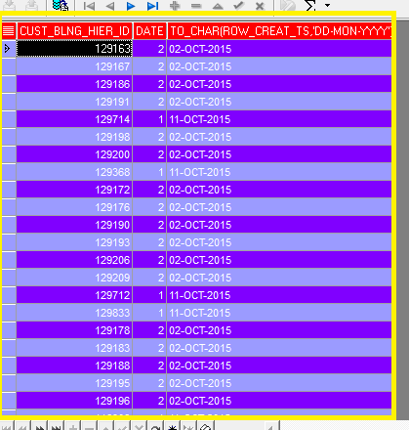

SQL Query to Convert the date to Julian date from CADM server.
select to_number(to_char(row_creat_ts,'J')) from hier_pnt_tb where row_creat_ts >= '01-OCT-2015' order by sysdate desc

SQL Query to change the time zone .
select cust_blng_hier_id ,to_char(cast(row_creat_ts as 'GMT') AT TIME ZONE 'US/Pacific','DD-MON-YYYY') from hier_pnt_tb

SQL Query to find the service name in Oracle .
select *from global_name;

GLOBAL_NAME
--------------------------------------------------------------------------------
CADMI1DB.DB.ATT.COM

SQL> decs dual;
SP2-0042: unknown command "decs dual" - rest of line ignored.
SQL> desc dual;
Name Null? Type
-------------------------------------- -------- --------------------------
DUMMY VARCHAR2(1)

SQL> select sys_context('USERENV' ,'SID') from dual;

SYS_CONTEXT('USERENV','SID')
---------------------------------------------------------------------------
13

SQL> select sys_context('USERENV' ,'db_name') from dual;

SYS_CONTEXT('USERENV','DB_NAME')
---------------------------------------------------------------------------
CADMI1DB

SQL> select sys_context('USERENV','sys_context' ) from dual;
select sys_context('USERENV','sys_context' ) from dual
*
ERROR at line 1:
ORA-02003: invalid USERENV parameter

SQL> select sys_context('USERENV','sys_instance') from dual;
select sys_context('USERENV','sys_instance') from dual
*
ERROR at line 1:
ORA-02003: invalid USERENV parameter

SQL> select sys_context('USERENV','instance_name') from dual;

SYS_CONTEXT('USERENV','INSTANCE_NAME')
---------------------------------------------------------------------------
CADMI1DB

To start the Oracle Database in LINUX OS, enter the following command to start the SQL Command Line and connect to the database:
sqlplus / as sysdba
The slash (/) indicates that the database should authenticate you with operating system authentication.
Query to find the host name
SQL> select UTL_INADDR.get_host_name from dual;
GET_HOST_NAME
IBMADM-HS3957

Or select host_name from v$instance

If you get an oracle error, 12541 TNS listener not found(ORA-12541. You check the status using the following command.Below is screen shot.
C:\Users\hs3957>lsnrctl status
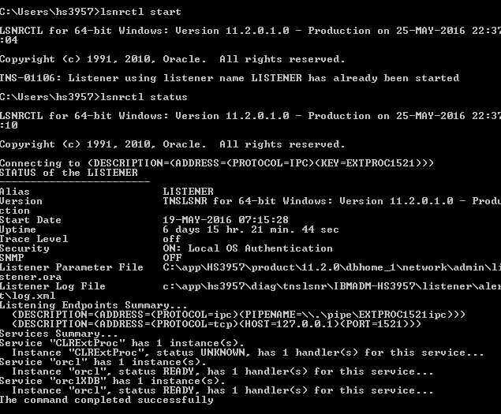
To start the service you can use following command to start ,stop
lsnrctl start , lsnrctl stop, lsnrctl reload

Export Tables with data from One DB to flat file and import to another DB or server.
$EXP ibm/ibm GRANTS=Y TABLES=EMP FILE=C:\sam.dmp

$IMP admin/admin GRANTS=Y TABLES=EMP FILE=C:\sam.dmp
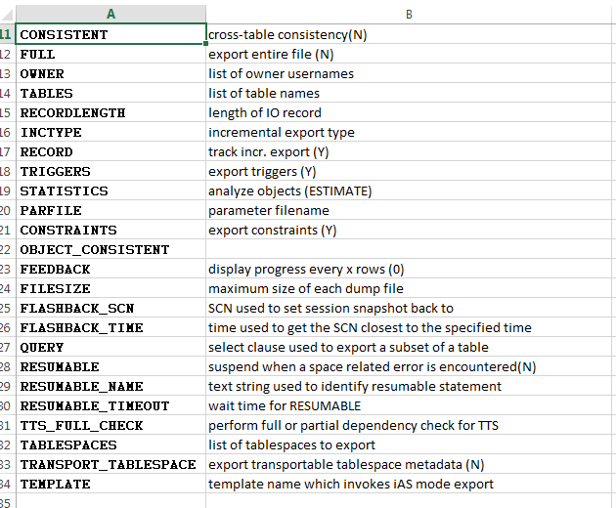
Example of Exporting Full Database
The following example shows how to export full database
$exp USERID=scott/tiger FULL=y FILE=myfull.dmp
In the above command, FILE option specifies the name of the dump file, FULL option specifies that you want to export the full database, USERID option specifies the user account to connect to the database. Note, to perform full export the user should have DBA or EXP_FULL_DATABASE privilege.
Example of Exporting Schemas
To export Objects stored in a particular schemas you can run export utility with the following arguments
$exp USERID=scott/tiger OWNER=(SCOTT,ALI) FILE=exp_own.dmp
The above command will export all the objects stored in SCOTT and ALI’s schema.
Exporting Individual Tables
To export individual tables give the following command
$exp USERID=scott/tiger TABLES=(scott.emp,scott.sales) FILE=exp_tab.dmp

Drop a table along with any object created like while installing the Informatica and other software.Need to specify the cascade option along with drop
DROP USER <USERNAME> cascade;

Need to read on single row function, Joins ,DDL,Group by
Single-row functions return a single result row for every row of a queried table or view. These functions can appear in select lists, WHERE clauses, START WITH and CONNECT BY clauses, and HAVING clauses.
About Save Point in SQL
Savepoint names must be distinct within a given transaction. If you create a second savepoint with the same identifier as an earlier savepoint, then the earlier savepoint is erased. After a savepoint has been created, you can either continue processing, commit your work, roll back the entire transaction, or roll back to the savepoint.
Examples
Creating Savepoints: Example To update the salary for Banda and Greene in the sample table hr.employees, check that the total department salary does not exceed 314,000, then reenter the salary for Greene:
UPDATE employees
SET salary = 7000
WHERE last_name = 'Banda';
SAVEPOINT banda_sal;

UPDATE employees
SET salary = 12000
WHERE last_name = 'Greene';
SAVEPOINT greene_sal;

SELECT SUM(salary) FROM employees;

ROLLBACK TO SAVEPOINT banda_sal;

UPDATE employees
SET salary = 11000
WHERE last_name = 'Greene';

COMMIT;

Create table syntax
create table SALES_TB (PRODUCT_ID NUMBER(10),PRODUCT VARCHAR2(30),PRICE1 NUMBER(10),PRICE2 NUMBER(10),PRICE3 NUMBER(10));
Alter table to add primary key.
Alter table sales_tb add primary key (product_id);

Need to read save point

Retrieve the odd and even rows from Oracle
select count(*),rownum from product_tb group by rownum having mod(rownum,2)=0 == Get even numer
select count(*),rownum from product_tb group by rownum having mod(rownum,2)<>0===Get Odd number

SQL Query to find the employees salary is less than ave salary.
select * from src_emp a where sal < ( select avg(sal) from src_emp b where a.DEPTNO= b.DEPTNO)
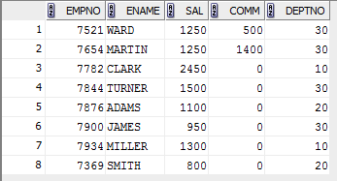

SQL Query to find the cumulative Salary .
Display all columns in the entire data base is below query
select TABLE_NAME,COLUMN_NAME,OWNER from all_tab_columns where OWNER='CADM_PART_1' order by table_name
desc all_tab_columns
Name Null Type
-------------------- -------- -------------
OWNER NOT NULL VARCHAR2(30)
TABLE_NAME NOT NULL VARCHAR2(30)
COLUMN_NAME NOT NULL VARCHAR2(30)
DATA_TYPE VARCHAR2(106)
DATA_TYPE_MOD VARCHAR2(3)
DATA_TYPE_OWNER VARCHAR2(120)
DATA_LENGTH NOT NULL NUMBER
DATA_PRECISION NUMBER
DATA_SCALE NUMBER
NULLABLE VARCHAR2(1)
COLUMN_ID NUMBER
DEFAULT_LENGTH NUMBER
DATA_DEFAULT LONG()
NUM_DISTINCT NUMBER
LOW_VALUE RAW(32 BYTE)
HIGH_VALUE RAW(32 BYTE)
DENSITY NUMBER
NUM_NULLS NUMBER
NUM_BUCKETS NUMBER
LAST_ANALYZED DATE
SAMPLE_SIZE NUMBER
CHARACTER_SET_NAME VARCHAR2(44)
CHAR_COL_DECL_LENGTH NUMBER
GLOBAL_STATS VARCHAR2(3)
USER_STATS VARCHAR2(3)
AVG_COL_LEN NUMBER
CHAR_LENGTH NUMBER
CHAR_USED VARCHAR2(1)
V80_FMT_IMAGE VARCHAR2(3)
DATA_UPGRADED VARCHAR2(3)
HISTOGRAM VARCHAR2(15)

SELECT ACCOUNT
, ENTRY_DATE
, AMOUNT
, SUM(AMOUNT) OVER (PARTITION BY ACCOUNT ORDER BY ENTRY_DATE) AS BALANCE
FROM ADAM_TEST1
ORDER BY ACCOUNT,ENTRY_DATE
Which results in:
ACCO ENTRY_DATE AMOUNT BALANCE
---- ----------- ---------- ----------
1000 01-JAN-2000 50 50
1000 02-JAN-2000 40 90
1000 03-JAN-2000 -50 40
1000 04-JAN-2000 10 50
1000 05-JAN-2000 -250 -200
1000 06-JAN-2000 100 -100
1000 07-JAN-2000 50 -50
2000 01-JAN-2000 30 30
2000 02-JAN-2000 10 40
2000 03-JAN-2000 -520 -480
2000 04-JAN-2000 140 -340
2000 05-JAN-2000 -4 -344
2000 06-JAN-2000 120 -224
2000 07-JAN-2000 57 -167

CADM Result for the cumulative sum calculation
select NON_USG_CSTM_ID,CSTM_AT ,CSTM_TYPE_CD , sum(CSTM_AT) OVER (PARTITION BY CSTM_TYPE_CD order by NON_USG_CSTM_ID) TOTAL from non_usg_cmpnt_tb
Note: If u do not select the order by in partition by last row sum will be written basis on partition column.
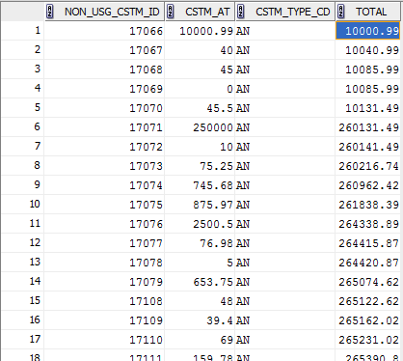

SIGN function will be used to find the -ve amount in column, If the amount is Zero it is will be displayed as Zero, If the amount is -ve it will be displayed as -1 and amount is +ve it will be displayed as 1 . Below is the screen shot from NON_USG_CMPNT_TB in CADM.
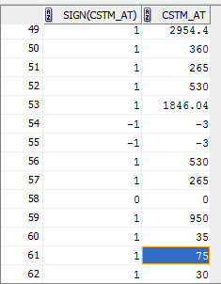

Analytical function count(*) . By using below query you can find out of SA for each CBH ID from CADM .
select cust_blng_hier_id,acct_1_nb,count(acct_1_nb) over(partition by cust_blng_hier_id) SA from hier_Pnt_tb where ub_acct_type_cd ='AS' order by SA desc
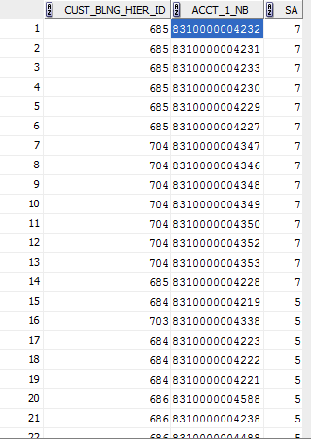
VIEW and METERIALIZED VIEWS
It stores the data based on remote table known as Snapshot .Materialized view can be updated fromoriginal base table from time to time . In materialized views index can be created.
Materialised view - a table on a disk that contains the result set of a query
Non-materiased view - a query that pulls data from the underlying table TO enable the Fast refresh we need to have primary in source table .
Difference between materialized view & Normal view
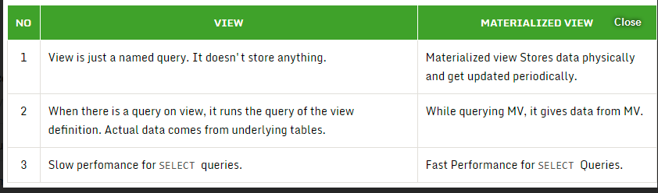
In view we can perform all operation like SQL Insert ,Update and Delete but in M view we can do only select operation .
If we drop base table view become invalid but If we drop the base table Materialized View never invalid.
DB Link is the one we can connect between 2 DB.
MV is used to reduce the network traffic especially business hours . It will not have real time data but it will have data till last refresh .
Create materialized view and create database link privileges required to create the MV.
Refresh Type.
Complete: Truncate + Insert fresh copy from base table.
Fast: Changes will only updated to MV, For this MV log is needed . Base table should have log .
In this refresh changes will be logged in MV log
FORCE:FAST refresh will be attempted , If not complete refresh will occur.
REFRESH EVENTS:It can be triggered in 2 ways .
ON DEMAND-
ON COMMIT-
To do Manual refresh DBMS_MVIEW.REFRESH (‘NAME_MV’, ‘C - completeor F- force’)

NUMWIDTH, FEED 1(DEFAULT is 6 ),PAGES, LINES – These are setting
Normal and Pre build – 2 types

Regular expression .
Regular expression is used to search the patterns in string data. For example we can search multiple match in single function as show below query will search for customer TC02 or TC01.
select * from ad_tb where REGEXP_LIKE(ad_1_nm, '223336c ETE (TC02|TC01)$')
REGEXP_INSTR,REGEXP_REPLACE,REGEXP_SUBSTR.
^ symbol will filter data starting with string provided .

SQL Query to find non numeric value
select * from ad_tb where GEO_CD is not null and regexp_like(geo_Cd ,'^[0-9]+$');

SQL Query to find the version of data base & screen shot that shows the output
SELECT * FROM v$version;
